Pizza Sales SQL Query

- KPI’s
- Total Revenue:
SELECT SUM(total_price) AS Total_Revenue FROM pizza_sales;

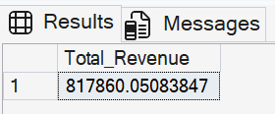

- Average Order Value:
SELECT (SUM(total_price) / COUNT(DISTINCT order_id)) AS Avg_order_Value FROM pizza_sales

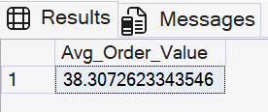

- Total Pizza Sold:
SELECT SUM(quantity) AS Total_pizza_sold FROM pizza_sales

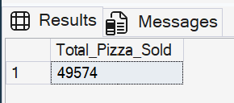

- Total Orders:
SELECT COUNT(DISTINCT order_id) AS Total_Orders FROM pizza_sales

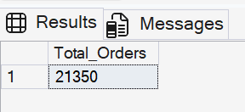

- Average Pizzas Per Order:
SELECT CAST(CAST(SUM(quantity) AS DECIMAL(10,2)) /
CAST(COUNT(DISTINCT order_id) AS DECIMAL(10,2)) AS DECIMAL(10,2))
AS Avg_Pizzas_per_order
FROM pizza_sales

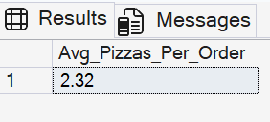

- Daily Trend of Total Orders:

Select DATENAME(DW, order_date ) as Order_Day , count(distinct order_id) AS Total_Orders from pizza_sales
group by DATENAME(DW, order_date)

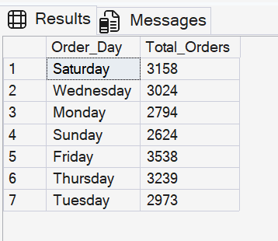

- Monthly Trend of Orders:

Select DATENAME(month, order_date ) as Month_Name , count(distinct order_id) AS Total_Orders from pizza_sales
group by DATENAME(month, order_date)
ORDER BY Total_Orders DESC

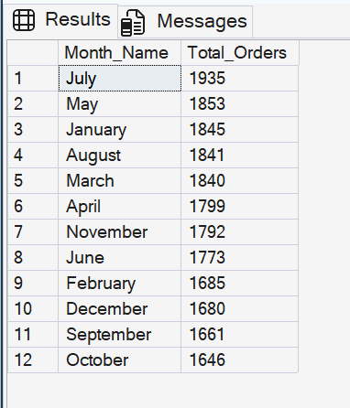
- % of Sales by Pizza Category:

select pizza_category, sum (total_price) as Total_Sales, sum (total_price) * 100 / (select sum (total_price)
from pizza_sales where month(order_date) = 1) as PCT
from pizza_sales
where month(order_date) = 1
group by pizza_category

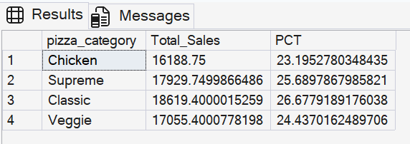

- % of Sales by Pizza Size:

select pizza_size, CAST( sum (total_price) AS DECIMAL(10,2)) as Total_Sales, CAST (sum (total_price) * 100 / (select sum (total_price)
from pizza_sales WHERE DATEPART (QUARTER, order_date) = 1) AS DECIMAL (10,2)) as PCT
from pizza_sales
WHERE DATEPART (QUARTER, order_date) = 1
group by pizza_size
order by PCT DESC

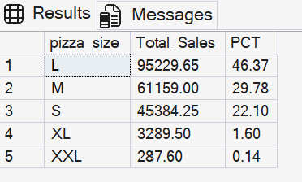

- Bottom 5 Pizzas by Revenue:

SELECT TOP 5 pizza_name, SUM( total_price) AS Total_Revenue FROM pizza_sales
GROUP BY pizza_name
ORDER BY Total_Revenue ASC

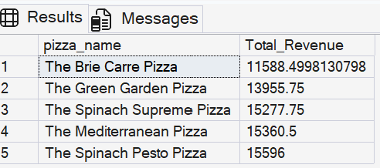

- Bottom 5 Pizzas by Revenue:

SELECT TOP 5 pizza_name, SUM( total_price) AS Total_Revenue FROM pizza_sales
GROUP BY pizza_name
ORDER BY Total_Revenue DESC

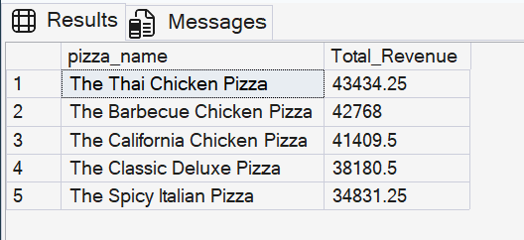

- Top 5 Pizzas by Quantity:

SELECT TOP 5 pizza_name, SUM(quantity) AS Total_Quantity FROM pizza_sales
GROUP BY pizza_name
ORDER BY Total_Quantity DESC

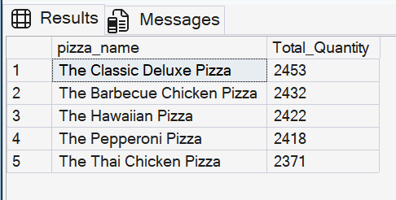

- Bottom 5 Pizzas by Quantity:

SELECT TOP 5 pizza_name, SUM(quantity) AS Total_Quantity FROM pizza_sales
GROUP BY pizza_name
ORDER BY Total_Quantity ASC

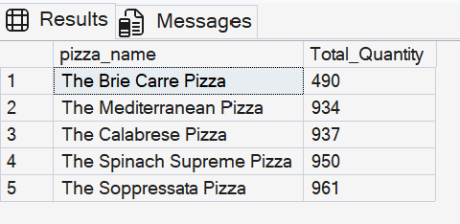

- Top 5 Pizzas by Total Orders:

SELECT TOP 5 pizza_name, COUNT (DISTINCT order_id) AS Total_Orders FROM pizza_sales
GROUP BY pizza_name
ORDER BY Total_Orders DESC

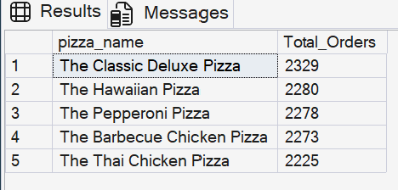

- Bottom 5 Pizzas by Total Orders :

SELECT TOP 5 pizza_name, COUNT (DISTINCT order_id) AS Total_Orders FROM pizza_sales
GROUP BY pizza_name
ORDER BY Total_Orders ASC

